**Assignment No.6**

Tejaswini Wanare

Roll no- 48

AI-C B2

**Title**

Design an Assignment to retrieve, verify, and store user credentials using Firebase Authentication, the Google App Engine standard environment, and Google Cloud Data store

**Steps**

a. Install required software as per the requirement

b. Install all the packages which are needed for firebase (firebase-admin , express etc) c. And follow the steps as per the references

**References**

https://firebase.google.com/docs/reference/admin

https://firebase.google.com/docs/auth/admin

https://firebase.google.com/docs/admin/setup

https://cloud.google.com/appengine/docs/standard/python/configuration-files https://livebook.manning.com/book/google-cloud-platform-in-action/chapter-11/

//-> D:\3rdYear\python-docs-samples\appengine\standard\firebase\firenotes>dev_appserver.py frontend/app.yaml backend/app.yaml

Google cloud console

Select create a project after get started

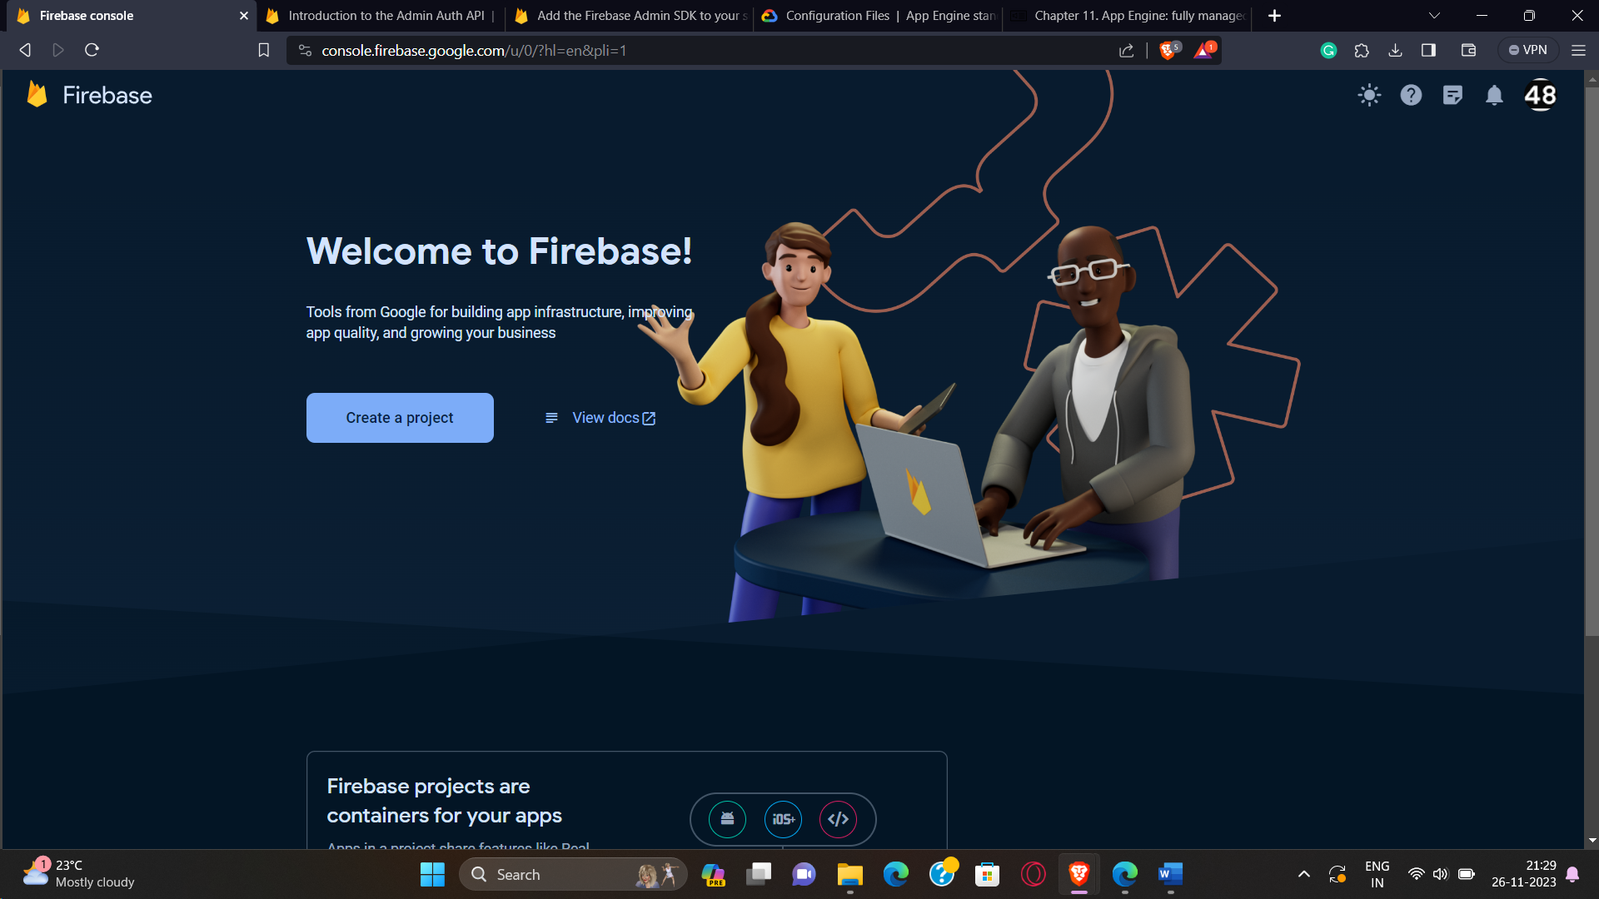

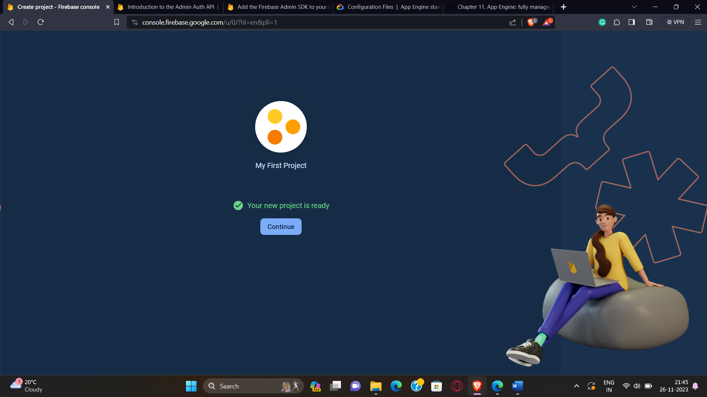

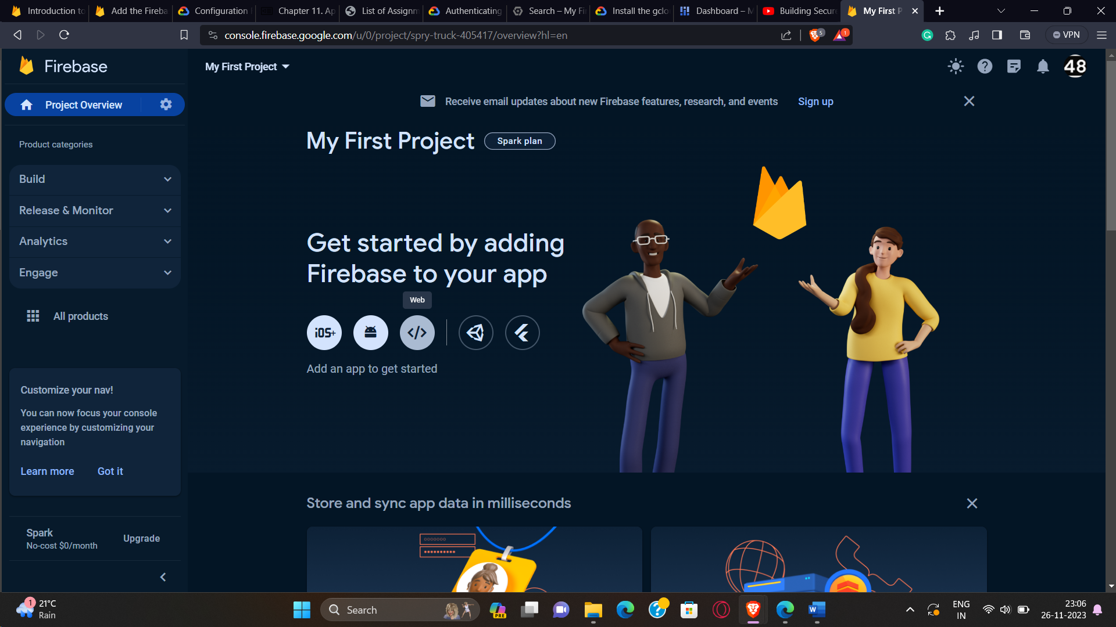

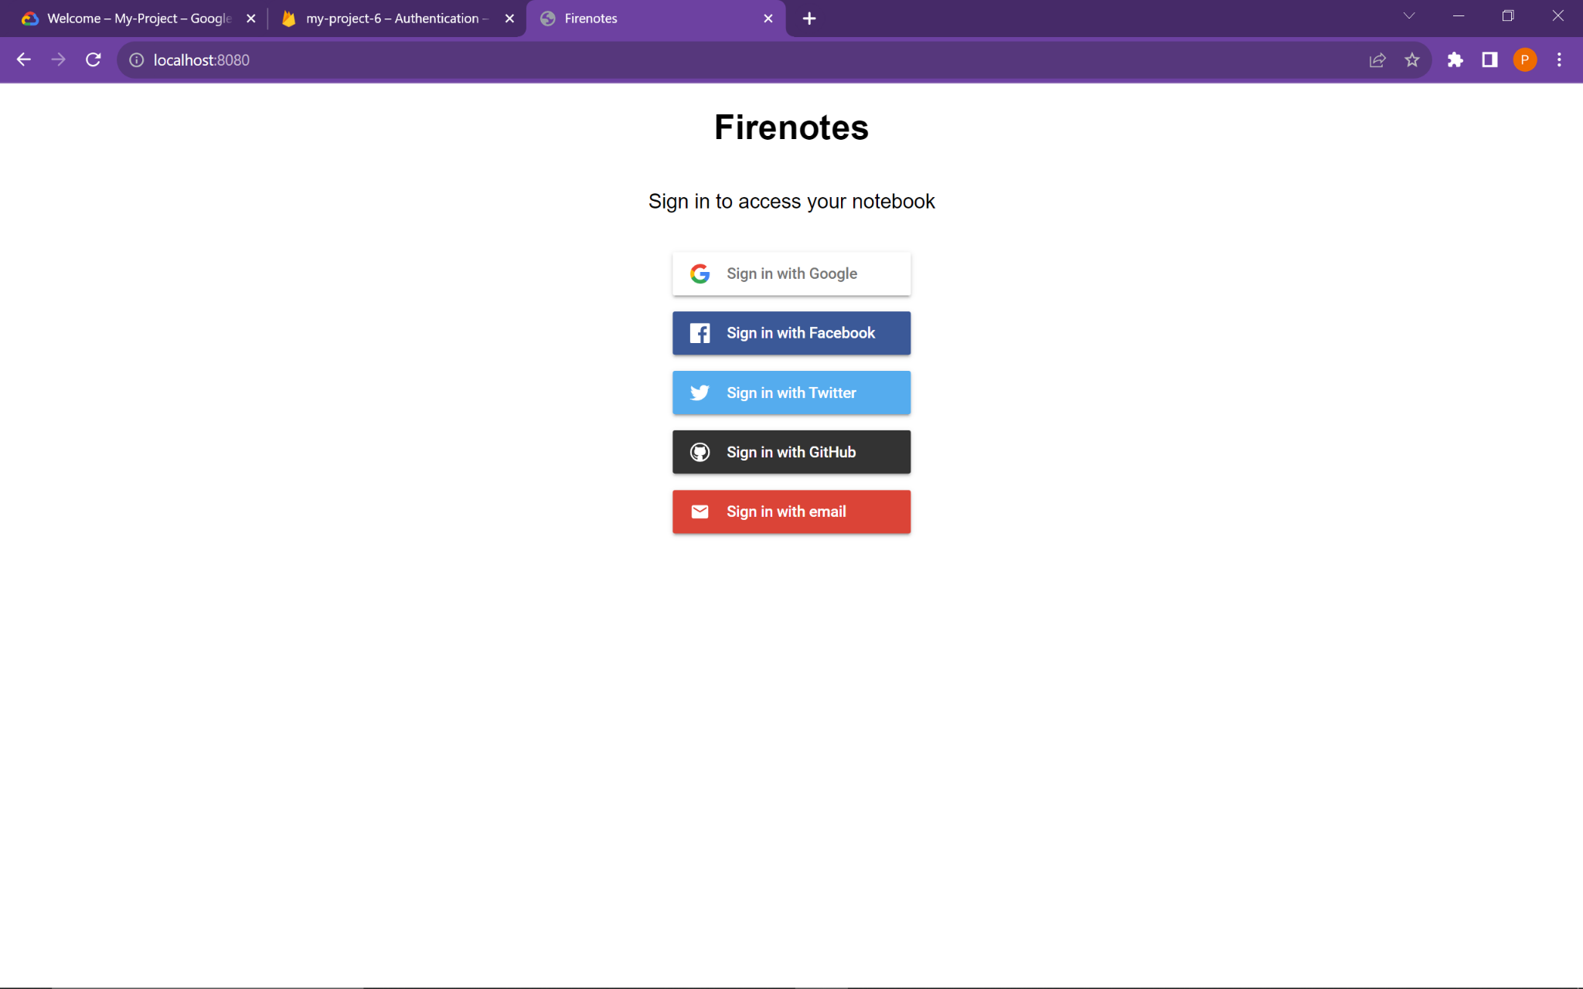

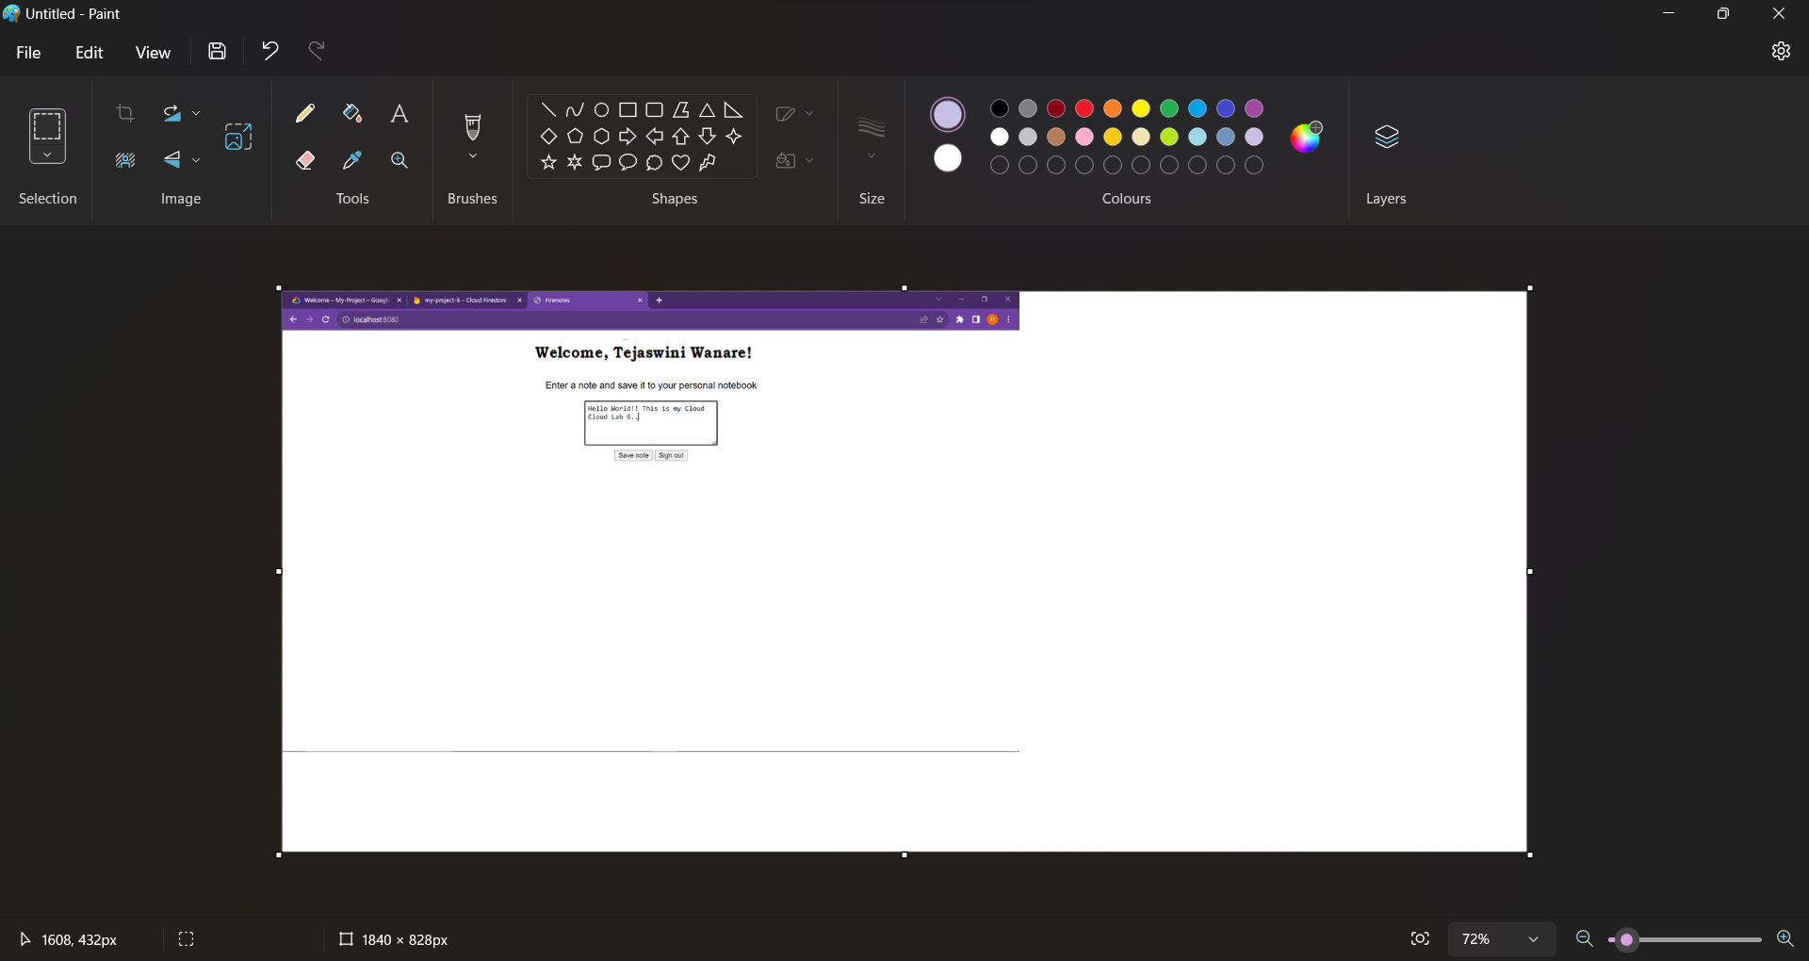

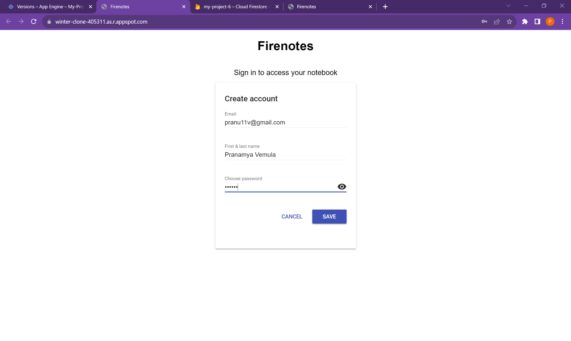

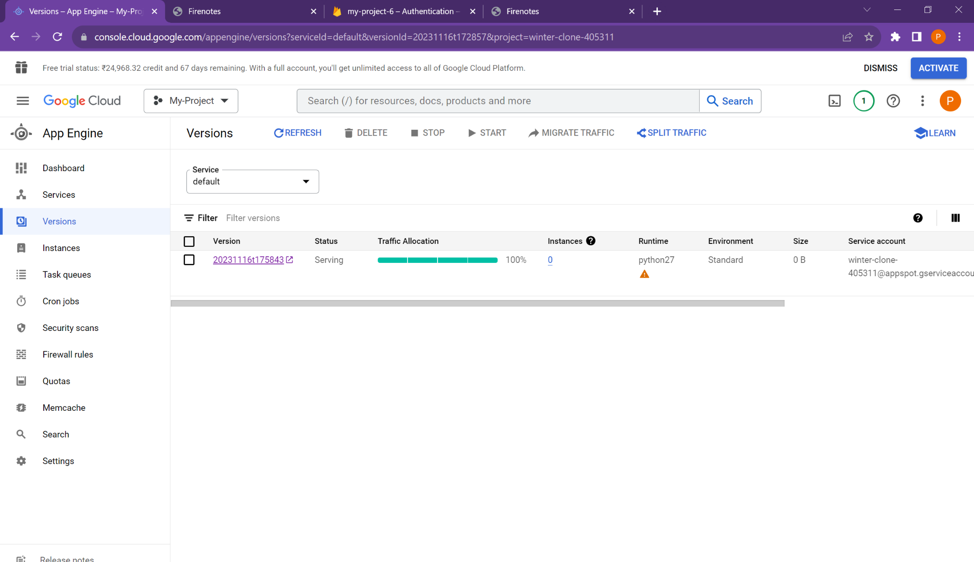

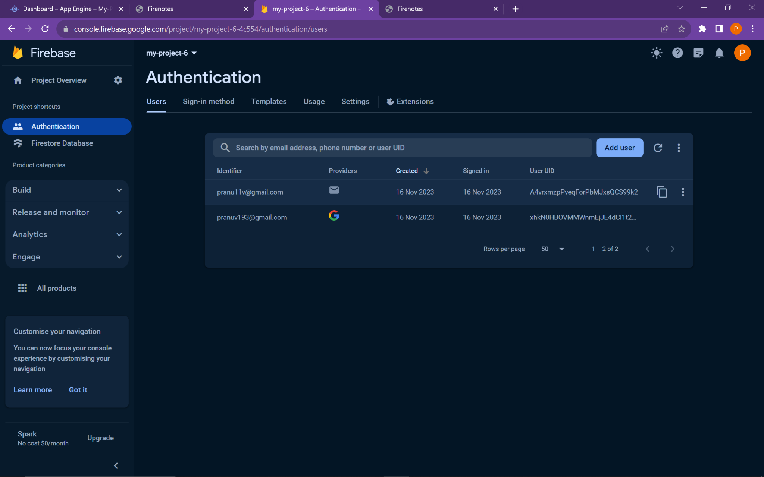

diditeju22@gmail.com

Create project on Firebase

In project settings, we get npm and initialize. For npm install javascript .js

On google cloud terminal,

Npm install firebase

On git

git clone https://github.com/GoogleCloudPlatform/python-docs-samples.git

cd python-docs-samples/appengine/standard/firebase/firenotes

Then go to python-docs-samples/appengine/standard/firebase/firenotes in file manager

In backend index.html,

Then , On git

cd backend/

pip install -t lib -r requirements]

Then on SDK

py google-cloud-sdk/bin/dev_appserver.py C:\Users\Tejaswini\python-docs samples\appengine\standard\firebase\firenotes\frontend\app.yaml

Open port localhost in browser.

Main.js